Title of the paper (style Title, Title Style SDS2016)
Author’s name and surname (style: Authors SDS2016)
Author’s name and surname (style: Authors SDS2016)
Author’s name and surname (style: Authors SDS2016)

Abstract (style: Abstract heading)
Abstract text, Abstract text, Abstract text, Abstract text, Abstract text, Abstract text, Abstract text, Abstract text, Abstract text, Abstract text, Abstract text, Abstract text, Abstract text, Abstract text, Abstract text, Abstract text, Abstract text, Abstract text, Abstract text, Abstract text, Abstract text, Abstract text, Abstract text, Abstract text, Abstract text, Abstract text... (style: Abstract text)
(max. 300 words)
Keywords: Keyword 1, Keyword 2, Keyword 3, etc. (max 5 words)
Introduction (style: Title of the paragraph)
Sustainable development (SD) is defined in the Brundtland Report as “development that meets the needs and aspirations of the present without compromising the ability of future generations to meet their own needs”. Thus, sustainable development is the organizing principle for sustaining finite resources necessary to provide for the needs of future generations of life on the planet… (style: Paragraph text)
Title of the paragraph (style: Title of the paragraph)
Sustainability can be defined as the practice of reserving resources for future generation without any harm to the nature and other components of it. Sustainable development ties together concern for the carrying capacity of natural systems with the social, political, and economic challenges faced by humanity. Sustainability science is the study of the concepts of sustainable development and environmental science... (style: Paragraph text)
Title of the paragraph (style: Title of the paragraph)
Integral elements for a sustainable development are research and innovation activities. A telling example is the European environmental research and innovation policy, which aims at defining and implementing a transformative agenda to greening the economy and the society as a whole so to achieve a truly sustainable development… (style: Paragraph text)
Title of the sub-paragraph (style: Title of the sub-paragraph)
Numerous sustainability standards and certification systems have been established in recent years, offering consumer choices for sustainable agriculture practices... (style: Paragraph text)
Table 1: Table title (style: Caption, Table title)
 | Title of the column | Title of the column
Title of the row | text/value | text/value
Title of the row | text/value | text/value
Title of the row | text/value | text/value
Title of the sub-paragraph (style: Title of the sub-paragraph)
Moreover, the depletion of natural and social capital may have non-linear consequences. Consumption of natural and social capital may have no observable impact until a certain threshold is reached... (style: Paragraph text)
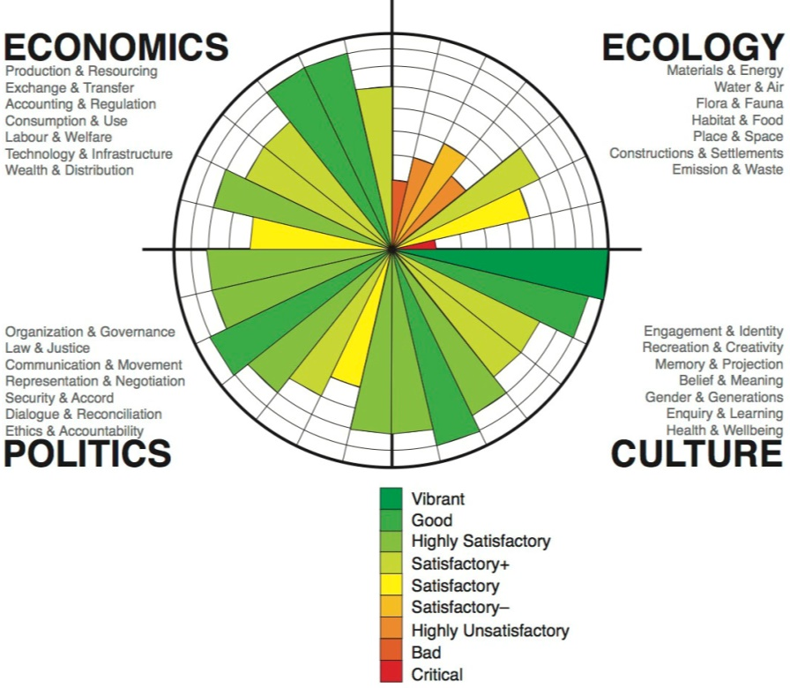
Figure 1: Figure title (style: Figure title) - Authors are requested to respect the copyrights of sources that have been taken from other authors or organizations. Figure size 300dpi
Conclusions (style: Title of the paragraph)
Sustainable development has its roots in ideas about sustainable forest management which were developed in Europe during the seventeenth and eighteenth centuries.[81][82] In response to a growing awareness of the depletion of timber resources in England, John Evelyn argued that "sowing and planting of trees had to be regarded as a national duty of every landowner... (style: Paragraph text)
References (style: Title of the paragraph)
Book:
Reigner, Jennifer. 1995. The Truth: The history of the future. New York: Pocket Books.
Book chapter:
Bourne, Michael, 1964. “Synthetic structure of industrial plastics.” In Plastics: Representation and Reality, edited by Faegheh Shirazi, 227–44. Austin: University of Texas Press.

Journal article:
Bogren, Alexandra. 2011. “Gender and Alcohol: The Swedish Press Debate.” Journal of Gender Studies 20, no. 2 (June): 155–69.
Internet source:
Google. 2012. “Privacy Policy.” Google Policies & Principles. Last modified July 27. Accessed January 3, 2013. http://www.google.com/policies/privacy/.
Blog entry or comment:
Becker, Gary. 2012. “Is Capitalism in Crisis?” The Becker-Posner Blog, February 12. Accessed February 16, 2012. http://www.becker-posner-blog.com/2012/02/is-capitalism-in-crisis-becker.html.
The list of references should be arranged alphabetically.

Additional note:
The paper should be named as follows: SDS2016 paper_name_surname.docx
Full papers should be submitted to sds2016granada@gmail.com
Authors are asked to respect and use established styles and defined maximum (6 pages including abstract, figures and references) for the full paper.

Name and Surname, Affiliation, Institution, Address, e-mail (style: Author data SDS2016)
Name and Surname, Affiliation, Institution, Address, e-mail (style: Author data SDS2016)
Name and Surname, Affiliation, Institution, Address, e-mail (style: Author data SDS2016)

